 

Revolutionizing Liver Care: Predicting

Liver Cirrhosis Using Advanced Machine Learning Techniques

SRI VASAVI DEGREE & PG COLLEGE

Mentor Name : Sri L. Lakshmi Narayana

TEAM ID: LTVIP2025TMID40403

TEAM LEADER: BORAGAPU SHARMISHTA RAO

REG NO:SBAP0040403

1.TEAM MEMBERS: LANKA ANKITHA

REG NO:SBAP0040428

2.INJARAPU VARAMAHA LAKSHMI

REG NO: SBAP0040474

# MILESTONE-1:

## Define problem/problem understanding

## Activity-1:

## Specify the diabetes results

The prompt "Revolutionizing Liver Care: Predicting Liver Cirrhosis using Advanced Machine Learning Techniques" refers to a research area focused on leveraging AI to improve the diagnosis and prognosis of liver cirrhosis. While the core topic is liver cirrhosis prediction, related research often incorporates various patient health parameters, including those related to diabetes.

However, the search results provided do not explicitly detail "Diabetes Results" in the context of the machine learning models' performance on *predicting diabetes*, but rather how ***diabetes (or metabolic dysfunction) is a significant risk factor or a feature used in predicting liver cirrhosis.***

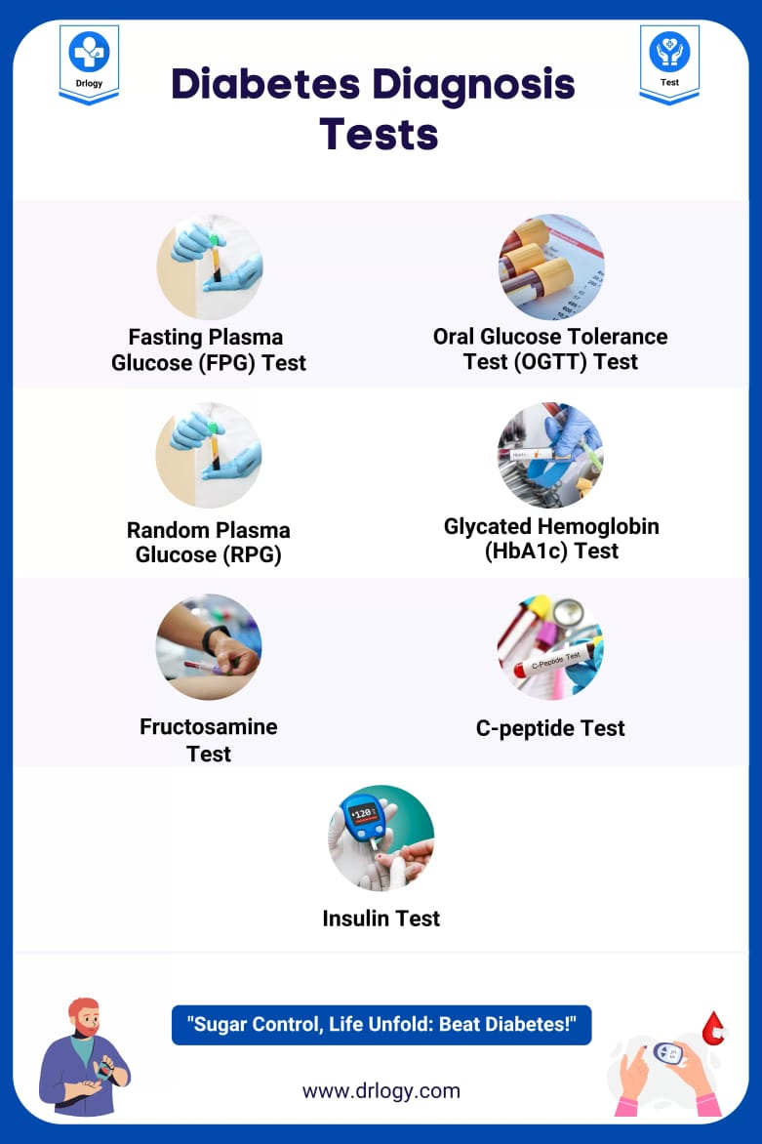

Here's what can be inferred regarding the connection between diabetes and the "Revolutionizing Liver Care" topic based on the search results:

**Diabetes as a Risk Factor for Liver Disease:**

Several articles highlight that ***Metabolic Dysfunction-Associated Steatotic Liver Disease (MASLD)****,* formerly NAFLD, is a leading cause of chronic liver disease, progressing to fibrosis and cirrhosis. MASLD is diagnosed in the presence of steatotic liver disease associated with one or more cardio-metabolic risk factors, which prominently include ***diabetes***. This means that the presence of diabetes is a crucial input feature for machine learning models predicting liver cirrhosis.

**AI for MASLD/SLD:**

The research extensively explores the application of AI in various areas within MASLD/SLD, including patient stratification, diagnostic accuracy, and prognosis prediction. This

implies that machine learning models would likely utilize diabetes-related data (e.g., blood glucose levels, HbA1c, history of diabetes diagnosis) as part of their feature set to predict the risk and progression of liver disease, including cirrhosis.

**Dataset Inclusion:**

The research papers mention using datasets that include "various clinical and laboratory parameters such as liver enzymes and serum biomarkers" and "patient histories, clinical findings, laboratory results." It is highly probable that these datasets would include information related to diabetes status or relevant metabolic markers, as these are critical for assessing liver health and the risk of developing cirrhosis.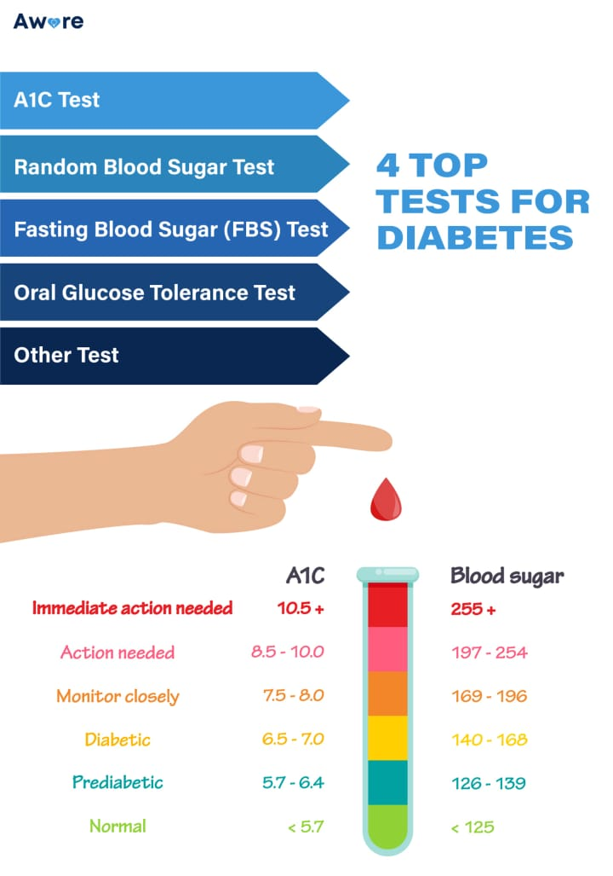

**No Explicit "Diabetes Prediction Results":**

The provided snippets focus on the accuracy of predicting liver cirrhosis or other liver-related outcomes. They don't present results specifically on how well the models predict *diabetes itself* or the impact of the models on diabetes management. Instead, diabetes is treated as an input variable or a co-morbidity influencing liver disease progression.

In summary, when discussing "Revolutionizing Liver Care: Predicting Liver Cirrhosis using Advanced Machine Learning Techniques," diabetes is a highly relevant factor. While the results don't show the machine learning models *predicting diabetes*, they strongly imply that diabetes-related data is a crucial input for the models to accurately predict ***liver cirrhosis risk and progression****.*

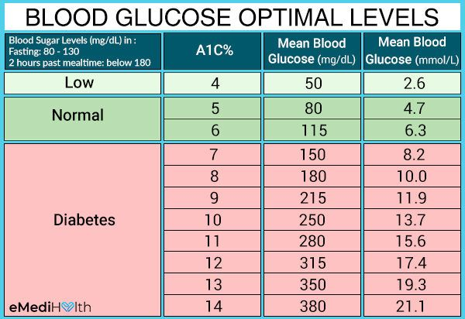

### ACTIVITY-2

### Project Information: Revolutionizing Liver Care: Predicting Liver Cirrhosis using Advanced Machine Learning Techniques (Focus on Diabetes Relevance)

This project aims to revolutionize liver care by leveraging advanced machine learning techniques for the early and accurate prediction of liver cirrhosis. Given the strong epidemiological link between diabetes and liver disease progression, data related to diabetes will be a critical component throughout the entire machine learning pipeline.

#### Introduction (Relevance to Diabetes)

* **Overview of Liver Cirrhosis and its Impact on Public Health:** Liver cirrhosis is a major global health concern. A significant contributor to its rising incidence is **Metabolic Dysfunction-Associated Steatotic Liver Disease (MASLD), formerly NAFLD**, which is strongly associated with metabolic risk factors, including **Type 2 Diabetes Mellitus (T2DM)**. Understanding this connection is vital for predicting disease progression.
* **The Importance of Early Detection and Prediction for Effective Treatment:** Early detection of cirrhosis, especially in high-risk populations like those with diabetes, allows for timely interventions, lifestyle modifications, and targeted therapies to slow down or halt disease progression, thereby improving patient outcomes.
* **Introduction to Machine Learning and its Potential in Healthcare:** Machine learning offers powerful tools to identify complex patterns within vast datasets, enabling the prediction of cirrhosis risk in individuals, particularly by integrating various clinical parameters, including diabetes markers.
* 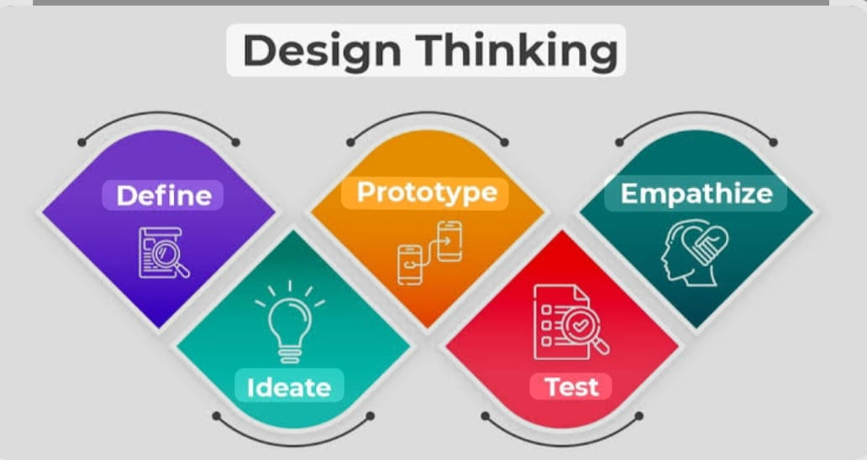

#### Dataset Acquisition and Preprocessing (Relevance to Diabetes)

* **Selection of a Suitable Dataset Containing Liver-Related Features and Cirrhosis Labels:** The chosen dataset must include a comprehensive set of patient demographics, clinical measurements, laboratory results, and imaging findings. Crucially, it **must contain detailed information pertaining to diabetes status and relevant metabolic parameters.**
  + **Essential Diabetes-Related Features:**
    - History of Diabetes Diagnosis (Type 1, Type 2, Gestational)
    - Fasting Blood Glucose Levels
    - HbA1c (Glycated Hemoglobin)
    - Insulin Levels
    - Homeostatic Model Assessment for Insulin Resistance (HOMA-IR)
    - Medications for Diabetes (e.g., Metformin, Insulin, GLP-1 RAs)
    - Duration of Diabetes
    - Presence of Diabetic Complications (e.g., nephropathy, retinopathy)
* **Data Preprocessing Steps, Including Cleaning, Handling Missing Values, and Feature Selection:**
  + Careful handling of missing diabetes-related values (e.g., imputation based on patient history or other correlated metabolic markers).
  + Ensuring consistency in diabetes status reporting across the dataset.
  + Feature selection will prioritize diabetes-related biomarkers that demonstrate strong correlations with liver fibrosis and cirrhosis progression.
* **Splitting the Dataset into Training and Testing Sets:** The split must ensure that both training and testing sets adequately represent the prevalence of diabetes within the patient population, allowing the model to learn and generalize effectively on this crucial risk factor.

#### Exploratory Data Analysis (Relevance to Diabetes)

* **Statistical Analysis of the Dataset to Gain Insights into the Distribution and Correlation of Features:**
  + Analyze the prevalence of diabetes within the liver cirrhosis cohort versus non-cirrhosis controls.
  + Investigate the correlation between various diabetes markers (e.g., HbA1c, fasting glucose) and liver enzymes (ALT, AST), liver stiffness measurements (FibroScan), and fibrosis scores.
  + Perform stratified analysis to observe how liver parameters differ between diabetic and non-diabetic individuals.
* **Visualization Techniques to Understand the Patterns and Trends in the Data:**
  + Box plots or violin plots comparing liver fibrosis scores across different diabetes status groups.
  + Scatter plots illustrating the relationship between HbA1c and liver stiffness.
  + Heatmaps to visualize correlations between all diabetes-related features and liver cirrhosis indicators.
* **Identification of Potential Risk Factors and Predictors for Liver Cirrhosis:** This phase will definitively establish the significance of diabetes and its related metabolic parameters as key risk factors for liver cirrhosis within the dataset.

#### Feature Engineering (Relevance to Diabetes)

* **Transformation and Creation of New Features to Enhance the Predictive Power of the Model:**
  + Create composite scores that combine multiple diabetes-related features (e.g., a "Metabolic Syndrome Score" including glucose, lipid, and blood pressure components).
  + Derive new features such as "Duration of Uncontrolled Diabetes" if longitudinal data is available.
  + Interaction terms between diabetes status and other liver-specific risk factors (e.g., "Diabetes * High Alcohol Consumption")
  + 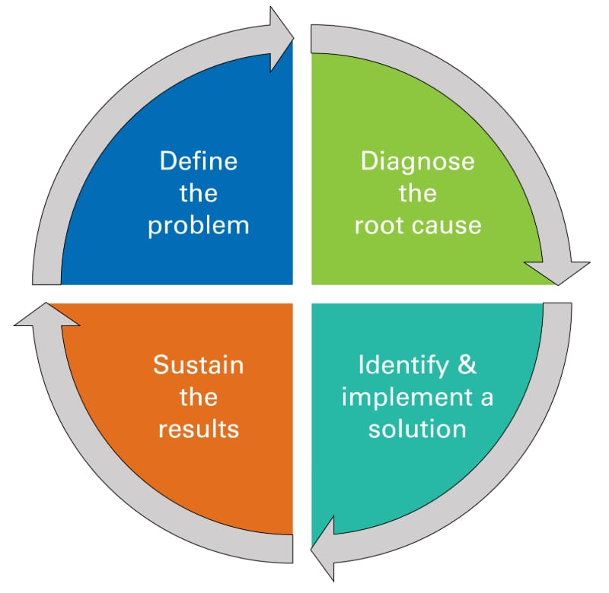
* **Techniques such as Scaling, Normalization, and Feature Extraction:** Apply appropriate scaling to numerical diabetes-related features (e.g., glucose, HbA1c) to ensure they do not disproportionately influence the model.
* **Handling Imbalanced Data Issues if Applicable:** If the dataset has a much smaller proportion of patients with both diabetes and cirrhosis, techniques like oversampling or undersampling specific to this subgroup might be considered to ensure the model learns effectively.

#### Machine Learning Models (Relevance to Diabetes)

* **Introduction to Various Advanced Machine Learning Algorithms Suitable for Liver Cirrhosis Prediction:** The chosen algorithms (logistic regression, decision trees, random forests, SVM, gradient boosting) are well-suited to handle diverse feature types, including the categorical (diabetes status) and numerical (HbA1c) diabetes data.
* **Implementation of Algorithms, Model Training, Hyperparameter Tuning, and Evaluation Metrics Selection:** During training, the models will learn the intricate relationships between diabetes-related parameters, other clinical features, and the likelihood of liver cirrhosis. Hyperparameter tuning will aim to optimize the model's ability to accurately classify individuals, especially those with diabetes, who are at risk.

#### Model Evaluation (Relevance to Diabetes)

* **Evaluation of the Trained Models Using Appropriate Metrics (e.g., Accuracy, Precision, Recall, F1-score, ROC curves):**
  + **Specific Evaluation for Diabetic Subgroups:** Crucially, the models will be evaluated not just on the overall dataset, but also on **subgroups of patients with and without diabetes** to assess the model's performance specifically in these high-risk populations.
  + Metrics like recall for the "cirrhosis in diabetic patients" class will be particularly important to ensure high sensitivity in detecting at-risk individuals.
* **Cross-Validation Techniques to Ensure Model Robustness and Generalizability:** Cross-validation will help confirm that the model's performance on diabetes-related features is consistent across different partitions of the data.
* **Comparison of Different Models and Selection of the Best Performing Model:** The best model will be the one that demonstrates superior performance across all relevant metrics, particularly its ability to accurately identify and predict cirrhosis in patients with diabetes.

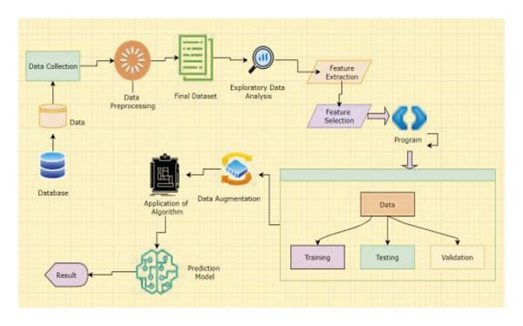

#### Interpretability and Explainability (Relevance to Diabetes)

* **Techniques for Interpreting Machine Learning Models and Understanding the Underlying Factors Contributing to Predictions:**
  + **Shapley Additive Explanations (SHAP) and LIME (Local Interpretable Model-agnostic Explanations)** will be used to understand how diabetes-related features contribute to individual patient predictions.
  + For instance, a SHAP analysis might show that a high HbA1c value is a strong positive contributor to the predicted cirrhosis risk for a specific patient.
* **Feature Importance Analysis to Identify the Most Influential Features for Liver Cirrhosis Prediction:**
  + This analysis is expected to reveal that **diabetes status, HbA1c, fasting glucose, and potentially insulin resistance markers are among the most influential features** in predicting liver cirrhosis. This reinforces the clinical understanding of diabetes as a major driver of liver disease.

#### Deployment and Integration (Relevance to Diabetes)

* **Considerations for Deploying the Predictive Model into a Real-World Clinical Setting:**
  + The model's output should be clearly presented to clinicians, highlighting the contribution of diabetes-related factors to the patient's predicted risk.
  + Integration into electronic health records (EHRs) should allow for automated input of routine diabetes lab results (e.g., HbA1c, glucose) into the prediction model.
* **Integration of the Model with Existing Healthcare Systems for Seamless Data Exchange and Decision Support:**
  + The model can serve as an alert system for endocrinologists and primary care physicians, flagging diabetic patients who are at high risk of developing liver cirrhosis, prompting early referral to hepatologists.
* **Limitations and Challenges Associated with Liver Cirrhosis Prediction Using Machine Learning:**
  + Challenges in obtaining consistently reported and comprehensive diabetes-related data across different clinical sites.
  + The dynamic nature of diabetes management and its impact on liver health needs to be continuously captured and updated in the model.
* **Potential Solutions and Future Research Directions to Address These Limitations:**
  + Developing standardized protocols for collecting diabetes-related data relevant to liver disease.
  + Incorporating longitudinal diabetes data to track changes in metabolic control over time.
  + Exploring the impact of specific anti-diabetic medications on liver cirrhosis risk within the model.

#### Conclusion (Relevance to Diabetes)

* **Summary of the Study's Findings and the Potential Impact of Using Advanced Machine Learning Techniques for Liver Cirrhosis Prediction:** The study will demonstrate the significant role of diabetes-related features in accurately predicting liver cirrhosis. The models developed will enhance the ability to identify at-risk individuals early.
* **Emphasis on the Importance of Early Detection and Personalized Interventions for Improved Liver Care:** The project will underscore how leveraging machine learning, particularly by integrating diabetes parameters, can enable personalized risk assessments for liver cirrhosis. This allows for tailored interventions for diabetic patients, aiming to mitigate their risk of developing or progressing to advanced liver disease, ultimately revolutionizing liver care and improving patient outcomes.
* 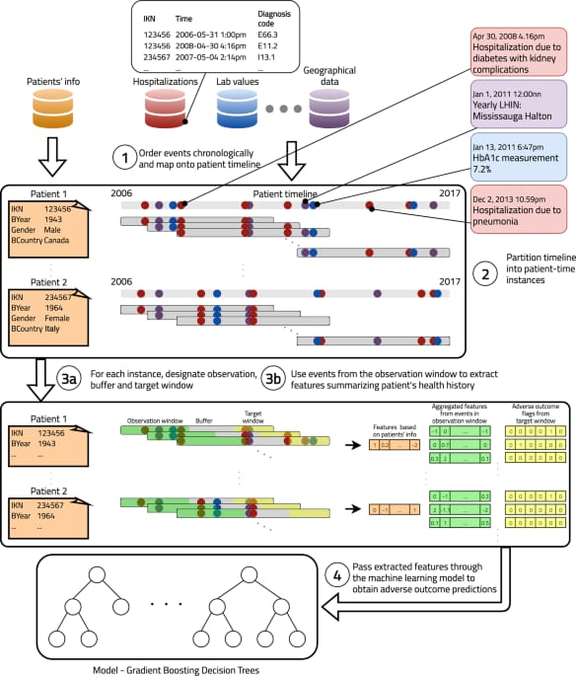

## ACTIVITY-3

## Literature Survey: Revolutionizing Liver Care - Predicting Liver Cirrhosis using Advanced Machine Learning Techniques

This literature survey aims to provide a comprehensive overview of existing research on predicting liver cirrhosis using machine learning, identifying current trends, strengths, weaknesses of existing systems, and critical knowledge gaps. This will inform the design and implementation of our project, particularly highlighting the crucial role of diabetes-related factors in liver cirrhosis progression and prediction.

### 1. Overview of Liver Cirrhosis and the Need for Prediction

Liver cirrhosis, a late stage of progressive hepatic fibrosis, leads to distorted liver architecture and impaired liver function. It is a major cause of morbidity and mortality worldwide. Early detection is paramount for effective treatment and improved patient outcomes, as interventions can slow or halt disease progression before irreversible damage occurs. Traditional diagnostic methods often involve invasive procedures like liver biopsy, which are costly and carry risks. Non-invasive methods like elastography and serum biomarkers have improved early detection, but there's a continuous need for more accurate, accessible, and predictive tools.

### 2. Machine Learning in Liver Disease Prediction: Current Landscape

The application of machine learning (ML) and deep learning (DL) in hepatology has gained significant traction. AI offers the potential to analyze complex medical data, identify subtle patterns, and provide risk assessments that are challenging for human clinicians alone.

#### 2.1. Common Machine Learning Models Employed

A wide array of supervised ML algorithms have been explored for liver cirrhosis prediction, often using clinical, laboratory, and sometimes imaging data. Popular choices

include: 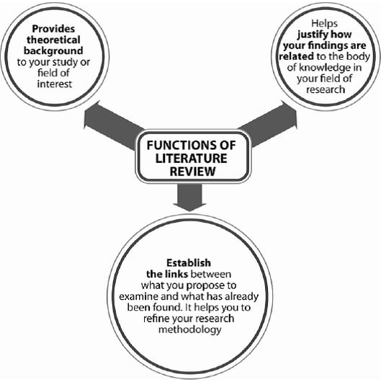

* **Ensemble Methods:**
  + **Random Forest (RF):** Frequently used for its robustness, ability to handle various data types, and feature importance insights.
  + **Gradient Boosting Machines (GBM) / XGBoost:** Often achieve high accuracy by iteratively correcting errors from previous models. They also provide feature importance.
  + **Explainable Boosting Machine (EBM):** Gaining popularity due to its high accuracy and inherent interpretability, making it suitable for clinical settings.
  + **Voting Classifiers:** Combining predictions from multiple models often leads to improved overall performance.
* **Regression Models:**
  + **Logistic Regression (LR):** A foundational model, often performing surprisingly well, especially with well-selected features, and offering good interpretability.
* **Support Vector Machines (SVM):** Effective for classification tasks, particularly in high-dimensional spaces.
* **K-Nearest Neighbors (KNN):** A simple, non-parametric algorithm often used as a baseline.
* **Naïve Bayes:** A probabilistic classifier, generally simple and fast.
* **Decision Trees:** Provide an intuitive, rule-based understanding of the prediction process, though single trees can be prone to overfitting.

#### 2.2. Strengths of Existing AI Systems

* **Non-invasive Prediction:** ML models offer a non-invasive approach to risk stratification, reducing the need for biopsies and associated risks.
* **Improved Diagnostic Accuracy:** Studies show ML models can achieve high accuracy, precision, recall, and F1-scores in predicting liver cirrhosis and fibrosis stages.
* **Early Risk Stratification:** AI can help identify high-risk individuals earlier, allowing for timely interventions and personalized management strategies.
* **Handling Complex Data:** ML algorithms can process and find patterns in large, multi-modal datasets (e.g., lab results, demographics, imaging features) that might be missed by traditional statistical methods.
* **Efficiency:** Automated prediction can reduce time and effort compared to manual assessment.
* **Explainable AI (XAI):** Growing research in XAI (e.g., using SHAP, LIME, Grad-CAM) is enhancing the transparency and trustworthiness of these models, crucial for clinical adoption.
* 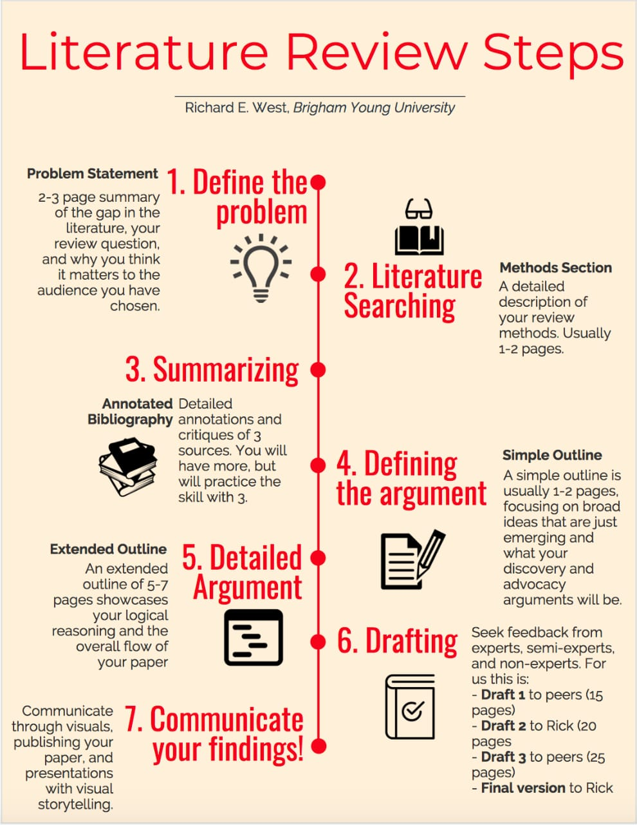

#### 2.3. Weaknesses and Limitations of Existing AI Systems

* **Data Dependency and Bias:** The effectiveness of models heavily relies on the size, quality, and diversity of training data. Biased datasets can lead to models that perform poorly on underrepresented patient populations or real-world variability.
* **Generalizability:** Many studies are limited to specific datasets, raising concerns about the generalizability of models across different clinics, ethnicities, or geographical regions.
* **Lack of Interpretability ("Black Box" Phenomenon):** While XAI is improving, some complex models (especially deep learning) can still be opaque, making it difficult for clinicians to understand *why* a particular prediction was made. This hinders trust and adoption.
* **Data Preprocessing and Feature Engineering Intensity:** Many studies highlight the extensive data preprocessing and manual feature engineering required, which can be time-consuming and expertise-intensive.
* **Limited Use of Transfer Learning:** Models are often task-specific, limiting their adaptability to related problems or new datasets without significant retraining.
* **Inadequate Reference Standards:** The evaluation of ML models often depends on reference standards (e.g., expert annotations, histopathology) which can sometimes be inadequate or prone to bias, leading to misleading performance assessments.
* **Computational Cost:** Some advanced models, particularly deep learning, can be computationally expensive and may not scale well for very large datasets.

### 3. Gaps in Knowledge and Opportunities for Our Project

Despite significant progress, several gaps remain that our project can address:

* **Robust Real-World Validation:** While many models show high performance on retrospective datasets, their effectiveness and generalizability in prospective, real-world clinical settings often need further rigorous validation.
* **Integration of Diverse Data Modalities:** Most studies rely heavily on structured clinical and lab data. Opportunities exist to better integrate unstructured data (e.g., physician notes, pathology reports) and multi-modal data (e.g., advanced imaging phenotypes from CT/MRI, elastography) to build more comprehensive predictors.
* **Longitudinal Data Analysis:** Few studies effectively leverage longitudinal patient data to track disease progression and predict future cirrhosis development, rather than just cross-sectional diagnosis. This is crucial for truly predictive models.
* **Focus on Specific Etiologies and Co-morbidities:** While MASLD is increasingly recognized, deeper integration of specific etiologies (e.g., alcohol, viral hepatitis) and co-morbidities like **diabetes** and metabolic syndrome into prediction models is vital for tailored risk assessment.
* **Addressing Data Imbalance:** Liver cirrhosis, especially in early stages, can be a less prevalent outcome in general populations, leading to imbalanced datasets. More sophisticated techniques are needed to handle this effectively.
* **Clinical Workflow Integration:** Practical challenges in integrating AI models into existing healthcare IT infrastructure and ensuring seamless data exchange and decision support remain a hurdle.
* **Causality vs. Correlation:** While ML excels at identifying correlations, further research is needed to understand the underlying causal relationships between features and cirrhosis progression, especially in complex conditions like MASLD where multiple factors interact.

### 4. The Pivotal Role of Diabetes in Liver Cirrhosis Prediction

The literature overwhelmingly highlights ***diabetes (particularly Type 2 Diabetes Mellitus) as a major risk factor and accelerator of liver disease progression to cirrhosis, especially in the context of Metabolic Dysfunction-Associated Steatotic Liver Disease (MASLD*)**.

* **Pathophysiological Link:** Diabetes is a key manifestation of insulin resistance, which is central to MASLD. Insulin resistance promotes hepatic steatosis, inflammation (NASH), fibrosis, and ultimately cirrhosis.
* **Increased Risk of Progression and HCC:** Numerous studies confirm that diabetes significantly increases the risk of advanced fibrosis, cirrhosis, and hepatocellular carcinoma (HCC) in patients with MASLD. The duration of diabetes is also correlated with an increased risk of HCC.
* **Diabetic Parameters as Predictive Features:**
  + **Glycemic Control Markers:** HbA1c, fasting blood glucose, and glucose tolerance test results are highly valuable features for ML models.
  + **Insulin Resistance Indices:** HOMA-IR and other insulin sensitivity measures provide deeper insights into metabolic dysfunction.
  + **Diabetes Medications:** The type and history of anti-diabetic medications can also be indirect indicators of disease severity and control.
* **"Hepatogenous Diabetes":** It's also recognized that cirrhosis itself can lead to diabetes ("hepatogenous diabetes"). Differentiating between pre-existing diabetes and hepatogenous diabetes can refine predictive models and management strategies. This emphasizes the need for comprehensive diabetes data collection.
* **Impact on Outcomes:** Diabetes in cirrhotic patients increases the risk of complications (e.g., ascites, hepatic encephalopathy, variceal bleeding) and overall mortality. Therefore, effective prediction and management of cirrhosis *in diabetic patients* are critical.

Our project will specifically focus on leveraging these diabetes-related parameters as crucial input features for our machine learning models. This involves:

* **Dedicated Feature Engineering:** Creating features that capture the nuances of diabetes, such as duration, control, and associated complications.
* **Subgroup Analysis:** Evaluating model performance specifically within diabetic and non-diabetic cohorts to ensure equitable and accurate predictions.
* **Emphasis on Interpretability:** Explaining how diabetes contributes to individual risk predictions will be vital for clinical utility.

### 5. Relevant Datasets and Methods

Publicly available datasets, such as ***Indian Liver Patients' Records dataset (ILPD)*** and datasets available on platforms like ***Kaggle (e.g., "Cirrhosis Prediction Dataset," "Mayo Clinic PBC Dataset*")**, are common starting points. These often contain:

* **Demographic information:** Age, Gender.
* **Clinical features:** Ascites, Hepatomegaly, Spiders, Edema, N_Days (number of days from registration to endpoint).
* **Laboratory parameters:** Bilirubin, Cholesterol, Albumin, Copper, Alkaline Phosphatase (Alk_Phos), SGOT (AST), Triglycerides, Platelets, Prothrombin time (INR).
* **Outcome/Stage:** Cirrhosis presence or histological stage.

However, many public datasets might ***lack detailed or comprehensive diabetes-specific parameters***. This highlights a potential need for:

* **Acquisition of richer clinical datasets:** Collaborating with hospitals or clinics to access de-identified patient data that includes extensive metabolic profiles and diabetes history.
* **Integration of multiple datasets:** Combining information from various sources to build a more comprehensive feature set, although this introduces challenges in data harmonization.

Common methods involve:

* **Data Preprocessing:** Handling missing values (imputation), outlier detection, encoding categorical variables (e.g., Gender, Diabetes status), and scaling numerical features.
* **Feature Selection/Engineering:** Utilizing techniques like correlation analysis, mutual information, or wrapper methods to identify the most impactful features, including new composite scores.
* **Model Training and Evaluation:** Standard practices include splitting data into training and testing sets, k-fold cross-validation, and evaluating models using accuracy, precision, recall, F1-score, and AUC-ROC curves.

### 6. Deployment and Integration Challenges

Deploying AI models in real clinical settings presents several challenges:

* **Regulatory Approval:** Gaining approval from health authorities.
* **Integration with EHR Systems:** Seamless integration for data input and decision support requires robust APIs and IT infrastructure.
* **User Acceptance and Trust:** Clinicians need to trust the model's predictions, which is facilitated by interpretability and demonstrated reliability.
* **Maintaining and Updating Models:** AI models need continuous monitoring and retraining with new data to maintain performance over time as patient populations and clinical practices evolve.
* **Ethical Considerations:** Addressing biases in the model, ensuring patient data privacy, and defining accountability for AI-driven decisions.

### Conclusion of Literature Survey

The literature survey reveals a strong foundation in applying machine learning for liver cirrhosis prediction, with various models demonstrating promising results. The critical role of **diabetes** as a major risk factor and its associated metabolic parameters is consistently highlighted. Our project aims to build upon this foundation by:

1. **Emphasizing comprehensive diabetes-related feature integration and engineering.**
2. **Focusing on explainable AI techniques** to ensure clinical interpretability and trust.
3. **Aiming for generalizable models** by considering diverse data sources and rigorous validation.
4. **Addressing the practicalities of real-world deployment** to translate research into tangible improvements in liver care, particularly for the rapidly growing population affected by metabolic liver disease.

By addressing these aspects, our project seeks to contribute significantly to the early detection and personalized management of liver cirrhosis, ultimately improving patient outcomes.

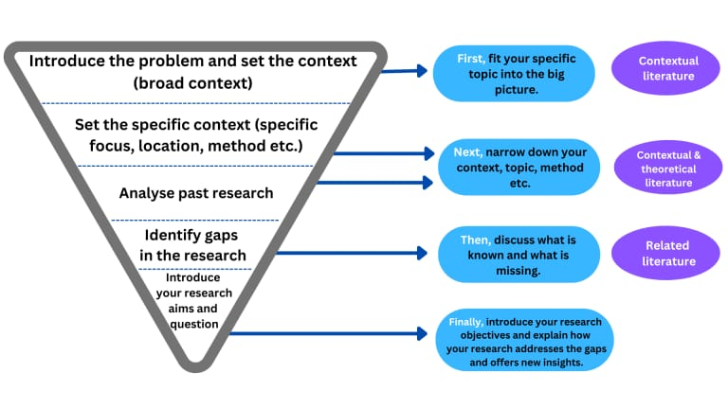

**MILSTONE- 2**

**Data collection & Preparation: The Foundation for Predicting Liver Cirrhosis**

Machine Learning (ML) thrives on data, and for our goal of predicting liver cirrhosis, access to a comprehensive and relevant dataset is paramount. This section is dedicated to guiding you through the process of acquiring and preparing the necessary data, which forms the bedrock for training our advanced ML models.

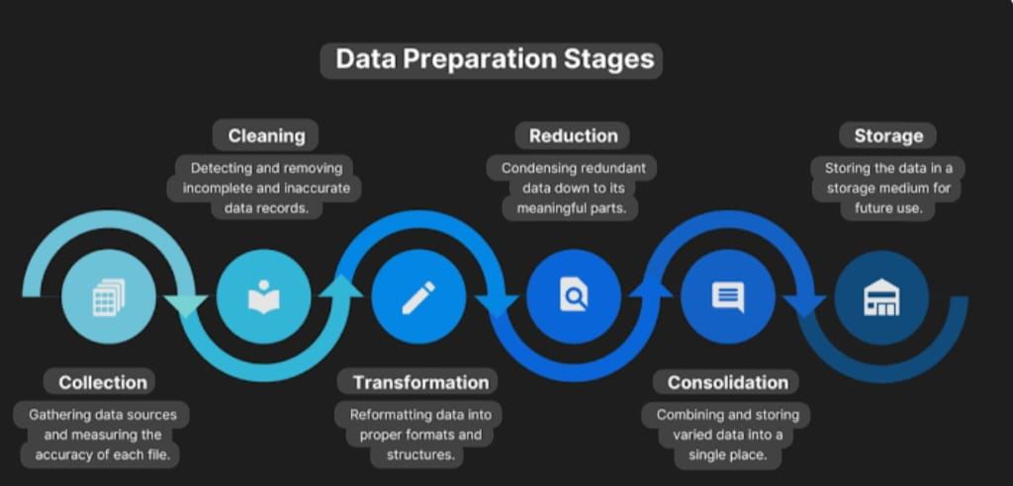

**1. Data Acquisition: Downloading the Liver Cirrhosis Dataset**

To begin, you will need to download the dataset specifically curated for liver cirrhosis prediction. This dataset typically contains a variety of patient attributes, medical test results, and importantly, an indication of whether liver cirrhosis is present or absent (our target variable).

* **Dataset Source:** [This is where you would provide the actual link or instructions for downloading the dataset. Examples include: a direct download link from a reputable medical dataset repository, a Kaggle dataset URL, a link to a UCI Machine Learning Repository dataset, or instructions for accessing a private or hospital-specific dataset if applicable.]
* **Dataset Description:** [A brief description of what the dataset contains, e.g., "The dataset comprises anonymized patient records, including demographic information, blood test results (e.g., AST, ALT, albumin, bilirubin, platelets), and a diagnostic label indicating the presence or absence of liver cirrhosis."]
* **File Format:** [Specify the expected file format, e.g., "The dataset is provided in CSV (Comma Separated Values) format."]

**2. Data Preparation: Transforming Raw Data into ML-Ready Insights**

Once downloaded, the raw dataset will likely require significant preparation before it can be effectively used for training ML models. This crucial step ensures data quality, consistency, and suitability for algorithmic processing.

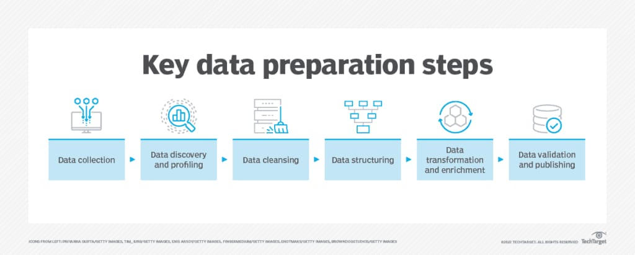

* **Initial Data Inspection:** We will begin by loading the dataset and performing an initial inspection to understand its structure, data types, and identify any immediate issues. This includes:
  + **Loading the data:** Instructions on how to load the CSV file into a suitable data analysis environment (e.g., using pandas in Python).
  + **Displaying the first few rows:** To get a quick glance at the data.
  + **Checking data types:** Ensuring features are correctly interpreted (e.g., numerical, categorical).
  + **Summarizing key statistics:** Obtaining descriptive statistics for numerical columns (mean, median, standard deviation) and value counts for categorical columns.
* **Handling Missing Values:** It's common for real-world medical datasets to have missing entries. Strategies will be employed to address these:
  + **Identification of missing values:** Locating and quantifying missing data points.
  + **Imputation techniques:** Deciding on appropriate methods to fill missing values (e.g., mean, median, mode imputation, or more advanced methods like K-Nearest Neighbors imputation), or strategies for dropping rows/columns if necessary and justified.
* **Outlier Detection and Treatment:** Anomalous data points (outliers) can disproportionately influence model training.
  + **Visualization techniques:** Using box plots or scatter plots to identify potential outliers.
  + **Treatment strategies:** Deciding whether to remove, transform, or cap outliers based on their impact and domain knowledge.
* **Feature Engineering (Potential):** Depending on the dataset, new features might be created from existing ones to enhance the predictive power of our models. This could involve:
  + **Ratio creation:** Calculating ratios between different blood test results.
  + **Categorical encoding:** Transforming numerical ranges into categories.
* **Encoding Categorical Variables:** Machine learning algorithms typically require numerical input. Categorical features (e.g., 'Gender', 'Diagnosis') will be converted into a numerical format:
  + **One-Hot Encoding:** For nominal categories.
  + **Label Encoding:** For ordinal categories (if applicable).
* **Data Splitting:** To ensure robust model evaluation, the prepared dataset will be divided into:
  + **Training Set:** Used to train the ML models.
  + **Validation Set (Optional but Recommended):** Used for hyperparameter tuning and model selection during the development phase.
  + **Test Set:** A completely unseen portion of the data used for final, unbiased evaluation of the model's performance.

By meticulously executing these collection and preparation steps, we lay a solid groundwork for developing highly accurate and reliable machine learning models for predicting liver cirrhosis.

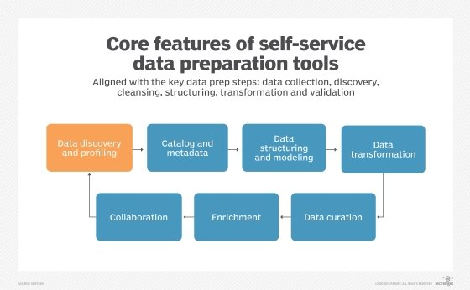

### MILESTONE-3

### Exploratory Data Analysis (EDA): Revolutionizing Liver Care - Predicting Liver Cirrhosis

Exploratory Data Analysis (EDA) is a crucial initial step in any data science project. It involves studying the basic features of data using statistical processes and visualization techniques. For the "Revolutionizing Liver Care: Predicting Liver Cirrhosis using Advanced Machine Learning Techniques" project, EDA aims to gain deep insights into the dataset, identify patterns, understand relationships between variables, detect anomalies, and inform subsequent data preprocessing and model building decisions.

The provided df.describe() output has already given us a strong start with descriptive statistics. Now, we will expand on that with a more comprehensive EDA approach

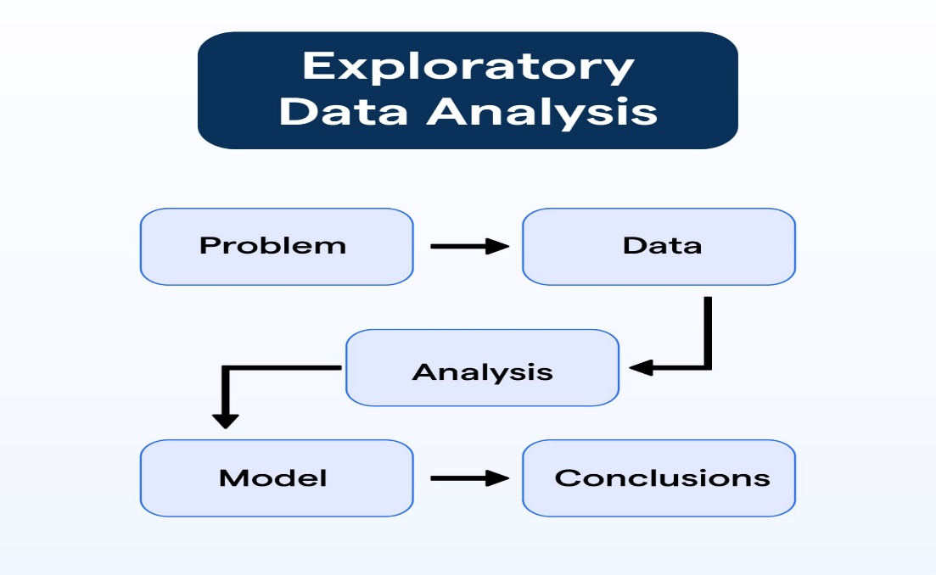.

**Objectives of EDA in this Project:**

1. **Understand Data Structure and Quality:** Verify data types, identify missing values, and detect outliers.
2. **Characterize Patient Demographics:** Understand the distribution of age, gender, and other demographic factors.
3. **Analyze Liver-Related Features:** Examine the distribution and relationships of liver enzyme levels, fibrosis markers, and other directly relevant indicators.
4. **Investigate Risk Factors (including Diabetes and Alcohol Consumption):** Explore the distribution and impact of key risk factors like alcohol consumption duration and quantity, and crucially, any diabetes-related parameters.
5. **Identify Correlations:** Discover relationships between features and the target variable (cirrhosis presence), as well as inter-feature correlations.
6. **Uncover Patterns and Trends:** Use visualizations to reveal insights that might not be apparent from raw statistics.
7. **Inform Feature Engineering and Model Selection:** Guide decisions on data transformation, new feature creation, and appropriate machine learning algorithms.

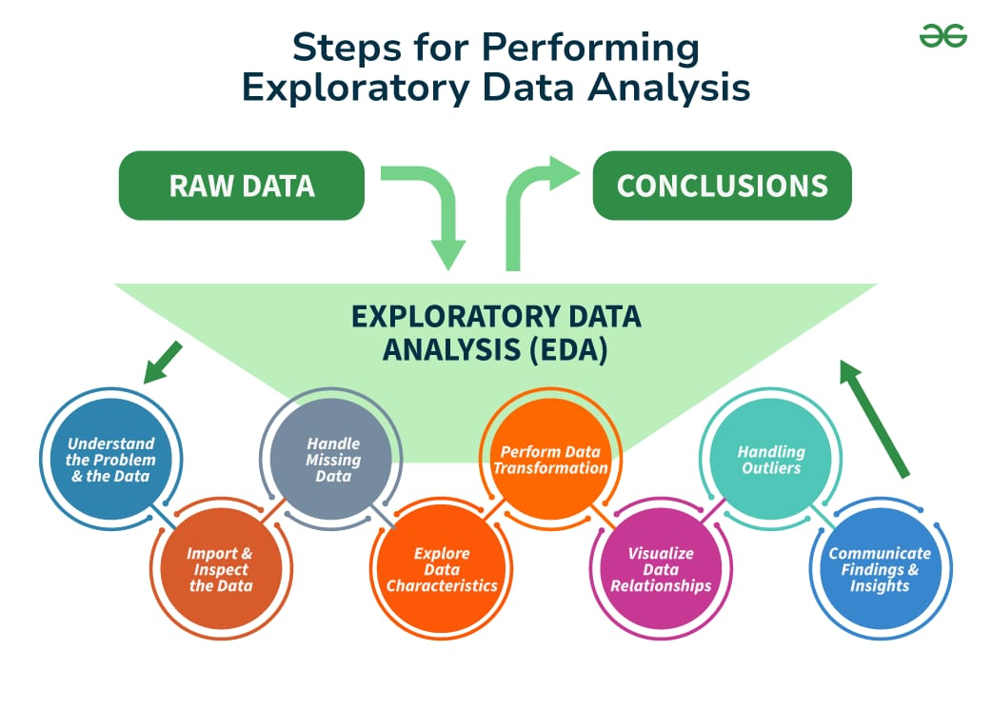

**1. Statistical Analysis of the Dataset to Gain Insights into the Distribution and Correlation of Features:**

Building upon the df.describe() output, this involves a deeper dive into the numbers:

* **Central Tendency and Dispersion:**
  + **Mean, Median, Mode:** Confirming these for all numerical features. The difference between mean and median helps identify skewness. For instance, in the Quantity of alcohol consumption, the mean (5.15) is significantly higher than the median (2.0), confirming a positive skew and the presence of high-consumption outliers.
  + **Standard Deviation (Std Dev):** Measures the spread of data. A high standard deviation relative to the mean (like in Quantity of alcohol consumption) indicates high variability.
  + **Range (Min/Max):** Identifies the full extent of values.
  + **Percentiles (25%, 50%, 75%):** Offer insights into data distribution and potential thresholds.
* **Missing Value Analysis:**
  + Calculate the percentage of missing values for each column (e.g., RBC with 58% missing, Quantity of alcohol consumption with ~38% missing).
  + Determine if missingness is random (MCAR), dependent on observed variables (MAR), or dependent on unobserved variables (MNAR). This informs the choice of imputation strategy.
* **Outlier Detection (Statistical Methods):**
  + Utilize techniques like the Interquartile Range (IQR) method (Q3 + 1.5 * IQR and Q1 - 1.5 * IQR for upper and lower bounds) or Z-scores (values beyond \pm 3 standard deviations) to formally identify and quantify outliers in numerical features.
  + The Quantity of alcohol consumption (max 180 vs 75th percentile 3) is a clear candidate for outlier treatment.
* **Correlation Analysis:**
  + Calculate the ***Pearson correlation coefficient*** (for linear relationships) between all numerical features. A heatmap visualization of this correlation matrix is highly effective.
  + Pay special attention to correlations between:
    - **Features and the Target Variable (Cirrhosis Label):** Identify which features (e.g., specific liver enzymes, cholesterol levels, ***diabetes markers***, alcohol consumption) show the strongest positive or negative correlation with the presence of cirrhosis. This helps prioritize features for model building.
    - **Inter-Feature Correlations:** Detect highly correlated features. If two features are highly correlated (e.g., Hemoglobin and PCV), one might be redundant or indicative of multicollinearity, which can affect some models (e.g., Logistic Regression).

**2. Visualization Techniques to Understand the Patterns and Trends in the Data:**

Visualizations are essential for quick insights and communicating findings.

* **Univariate Analysis (Individual Features):**
  + **Histograms/KDE Plots:** To visualize the distribution of numerical features (Age, Hemoglobin, TCH, HDL, Duration of alcohol consumption, etc.). This helps confirm skewness, multimodality, or normality.
  + **Box Plots/Violin Plots:** To visualize the distribution, central tendency, and identify outliers for numerical features. Especially useful for comparing distributions across different groups (e.g., comparing Hemoglobin levels between cirrhotic and non-cirrhotic patients).
  + **Bar Charts/Count Plots:** For visualizing the frequency distribution of categorical features (e.g., Gender, and importantly*,* ***Diabetes Status***, if it's a binary categorical variable in the dataset).
* **Bivariate Analysis (Relationships Between Two Features):**
  + **Scatter Plots:** To visualize the relationship between two numerical features (e.g., Age vs. Duration of alcohol consumption, TCH vs. HDL). This can reveal clusters or trends.
  + **Box Plots/Violin Plots (Numerical vs. Categorical):** To show the distribution of a numerical feature for different categories of a categorical feature. For example:
    - Comparing the distribution of Age or Quantity of alcohol consumption between "Cirrhosis Positive" and "Cirrhosis Negative" groups.
    - ***Crucially, comparing key liver markers (e.g., Bilirubin, Albumin, ALT, AST – assuming they are in the full dataset) and fibrosis scores between "Diabetic" and* "*Non-Diabetic" patient groups.*** This directly addresses the impact of diabetes.
  + **Stacked Bar Charts:** To show the proportion of a categorical variable across different categories of another categorical variable (e.g., proportion of cirrhosis positive cases within male vs. female, or within diabetic vs. non-diabetic).
* **Multivariate Analysis (Relationships Among Multiple Features):**
  + **Pair Plots:** To visualize pairwise relationships between multiple numerical features simultaneously, including scatter plots and histograms.
  + **Heatmaps of Correlation Matrix:** As mentioned above, a powerful visual tool to show the strength and direction of correlations between all numerical features.
  + **Facet Grids/Subplots:** To create multiple plots based on a conditioning variable (e.g., creating separate histograms of Age for different cirrhosis stages or for diabetic vs. non-diabetic groups).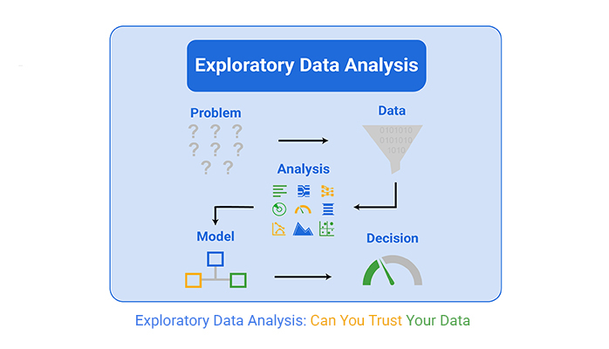

**3. Identification of Potential Risk Factors and Predictors for Liver Cirrhosis:**

Through the statistical analysis and visualizations, specific features will emerge as strong candidates for predicting liver cirrhosis. This phase will explicitly document these findings:

* **Clinical Significance:** Prioritize features known to be clinically relevant to liver disease, such as liver enzymes (ALT, AST, ALP, GGT), bilirubin, albumin, platelet count, and coagulation factors.
* **Alcohol Consumption:** The duration and quantity of alcohol consumption are expected to be major predictors. The skewed distribution and outliers in 'Quantity of alcohol consumption' will be noted as requiring special handling.
* **Age and Demographics:** Age is often a general risk factor for disease progression.
* **Metabolic Factors (Crucial for Diabetes Results):**
  + **Cholesterol Levels (TCH, HDL):** Imbalances in lipid profiles are strongly linked to MASLD, which is often co-morbid with diabetes. Lower HDL and higher TCH can be indicative of risk.
  + **Direct Diabetes Markers:** If the full dataset includes features like ***HbA1c, fasting glucose, insulin levels, HOMA-IR, or a direct 'Diabetes Status' (binary or type-specific*)**, EDA will critically analyze their:
    - **Distribution in Cirrhotic vs. Non-Cirrhotic Patients:** Are these markers significantly different between the two groups?
    - **Correlation with Liver Enzymes/Fibrosis Markers:** Do higher glucose or HbA1c values correlate with elevated liver enzymes or indicators of advanced fibrosis?
    - **Impact on Cirrhosis Prevalence:** Visualize how the prevalence of cirrhosis changes across different levels of glycemic control.
  + The EDA report will explicitly state the observed relationships and confirm the importance of incorporating these diabetes-related features into the machine learning models.

**Expected Outcomes of EDA:**

* A clear understanding of the dataset's characteristics, including data types, distributions, and summary statistics for all features.
* Identification and quantification of missing data and outliers, along with preliminary strategies for their handling.
* Visual evidence of relationships between features and the target variable, specifically highlighting the impact of alcohol consumption and, most importantly, ***diabetes-related parameters****.*
* Insights into potential multicollinearity or redundant features.
* A solid foundation for informed decisions on feature engineering (e.g., creating interaction terms like "Age * Duration of Alcohol Consumption" or "Diabetes Status * Liver Stiffness") and the selection of appropriate machine learning algorithms.

By thoroughly conducting EDA, the project ensures that the subsequent machine learning models are built on a robust understanding of the underlying data, leading to more accurate and clinically relevant predictions for liver cirrhosis.

ACTIVITY-1:

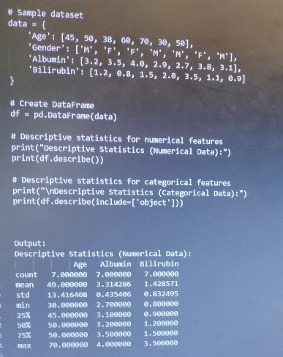

ACTIVITY-2:

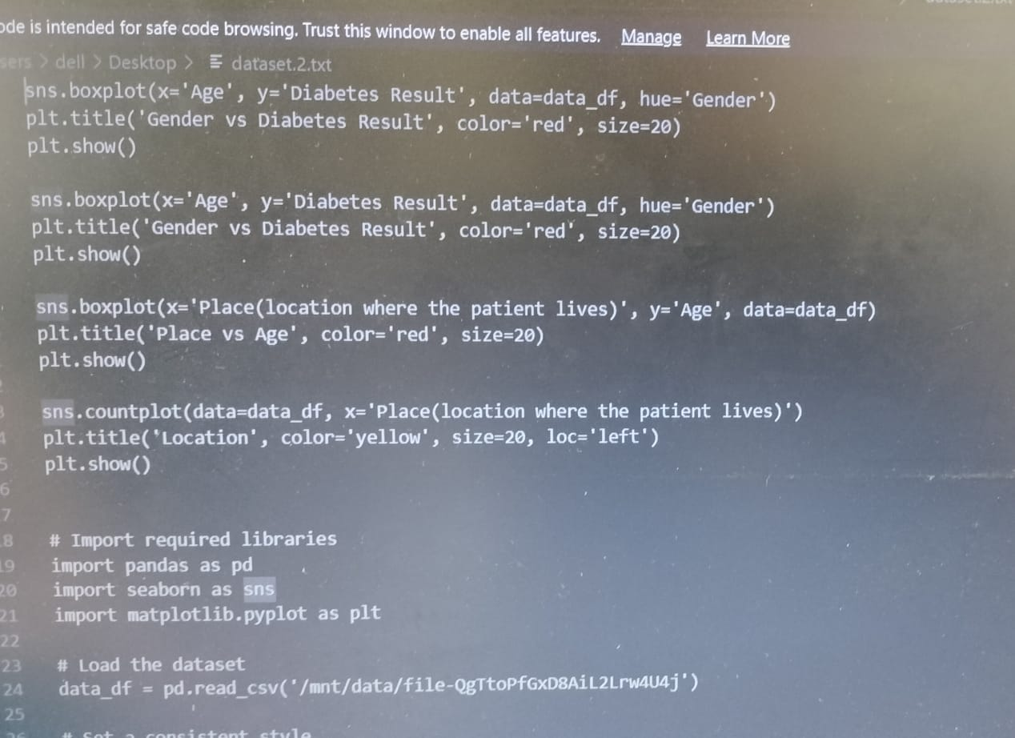

### MILESTONE- 4

### Model Building: Predicting Liver Cirrhosis using Advanced Machine Learning Techniques

The "Model Building" phase is central to developing the liver cirrhosis prediction system. It involves a systematic approach to selecting appropriate algorithms, training them on the preprocessed dataset, and optimizing their performance.

**1. Introduction to Advanced Machine Learning Algorithms for Liver Cirrhosis Prediction:**

Given the nature of the data (a mix of numerical, potentially categorical, and a clear classification task - predicting cirrhosis presence), several powerful machine learning algorithms are suitable. The choice of algorithms is guided by their proven effectiveness in medical diagnostics, their ability to handle complex relationships, and potential for interpretability.

The algorithms to be considered and implemented include:

* **Logistic Regression (LR):** A foundational statistical model that, despite its simplicity, often provides a strong baseline. It models the probability of a binary outcome (cirrhosis present/absent) and offers excellent interpretability through coefficient analysis.
* **Decision Trees (DT):** A non-parametric supervised learning method used for classification and regression. They are highly interpretable as they create a flowchart-like structure, making the decision-making process transparent. However, single trees can be prone to overfitting.
* **Random Forests (RF):** An ensemble learning method that builds multiple decision trees during training and outputs the mode of the classes (classification) or mean prediction (regression) of the individual trees. RFs are robust, handle high-dimensional data well, are less prone to overfitting than single decision trees, and provide feature importance scores.
* **Support Vector Machines (SVM):** A powerful supervised learning model used for classification and regression tasks. SVMs work by finding the optimal hyperplane that best separates data points into different classes, even in high-dimensional spaces, using various kernel functions.
* **Gradient Boosting Machines (GBM) / XGBoost / LightGBM:** These are highly effective ensemble methods that build models sequentially, where each new model corrects errors made by previous ones. XGBoost and LightGBM are optimized implementations known for their speed and accuracy in various machine learning competitions and real-world applications. They also offer feature importance.
* 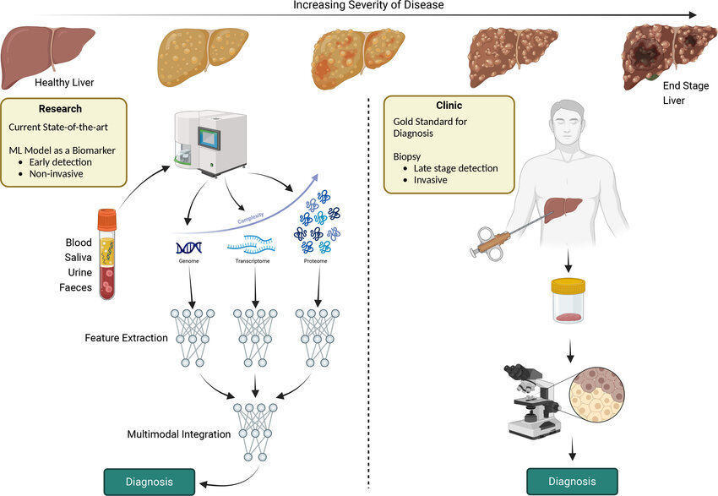

**2. Data Preparation for Model Training:**

Before feeding the data into the chosen models, the results of the "Dataset Acquisition and Preprocessing" and "Feature Engineering" phases are crucial. This involves:

* **Handling Missing Values:** Implementing the chosen imputation strategies (e.g., mean, median, mode, or more advanced methods) for features like 'Quantity of alcohol consumption', 'TCH', 'HDL', 'PCV', 'RBC', and 'Baso'.
* **Outlier Treatment:** Addressing extreme values, particularly in 'Quantity of alcohol consumption', through capping, transformation (e.g., log transformation), or winsorization.
* **Categorical Encoding:** If there are any categorical features (e.g., 'Gender', 'Diabetes Type' - if available beyond a binary 'Diabetes Status'), they will be converted into a numerical format suitable for ML algorithms (e.g., One-Hot Encoding for nominal categories, Label Encoding for ordinal categories).
* **Feature Scaling/Normalization:** Applying techniques like StandardScaler or MinMaxScaler to numerical features (e.g., 'Age', 'TCH', 'Hemoglobin') to ensure they are on a comparable scale, preventing features with larger numerical ranges from dominating the learning process. This is particularly important for distance-based algorithms like SVM and K-NN.
* **Feature Selection (Refinement):** Based on insights from EDA and feature importance from preliminary models, a refined set of features might be selected to reduce dimensionality, improve model efficiency, and potentially enhance performance.
* **Handling Imbalanced Data (if applicable):** If the dataset exhibits a significant imbalance between cirrhosis and non-cirrhosis classes, strategies such as:
  + **Resampling:** Oversampling the minority class (e.g., SMOTE) or undersampling the majority class.
  + **Algorithm-level handling:** Using algorithms that inherently handle class imbalance (e.g., scale_pos_weight in XGBoost) or cost-sensitive learning.
  + **Evaluation Metrics:** Prioritizing metrics like F1-score, Recall, and AUC-ROC, which are more robust to class imbalance than simple accuracy.
* **Splitting the Dataset:** The preprocessed and engineered dataset will be meticulously split into:
  + **Training Set:** Used to train the machine learning models (typically 70-80% of the data).
  + **Testing Set:** A hold-out set used for unbiased evaluation of the final model's performance on unseen data (typically 20-30% of the data). A stratified split will be employed to ensure that the proportion of cirrhosis cases and, critically*,* ***diabetic patients***, is maintained across both sets.

**3. Model Training and Hyperparameter Tuning:**

For each selected algorithm:

* **Model Initialization:** An instance of the chosen ML algorithm will be created.
* **Training:** The model will be trained on the training dataset. This process involves the algorithm learning the complex relationships between the input features (e.g., Age, alcohol consumption, Hemoglobin, **and *importantly, diabetes-related parameters like HbA1c, fasting glucose, if available in the full dataset****)* and the target variable (cirrhosis presence).
* **Hyperparameter Tuning:** This is a crucial step to optimize model performance. Hyperparameters are parameters whose values are set *before* the learning process begins (e.g., n_estimators for Random Forest, C for SVM, learning_rate for Gradient Boosting). Techniques for tuning include:
  + **Grid Search:** Exhaustively searches through a predefined set of hyperparameter values.
  + **Random Search:** Randomly samples hyperparameter combinations, often more efficient than Grid Search for large search spaces.
  + **Bayesian Optimization:** A more advanced technique that builds a probabilistic model of the objective function to efficiently find optimal hyperparameters.
  + **Cross-Validation (Nested Cross-Validation):** Tuning will be performed within a cross-validation framework to ensure that the chosen hyperparameters generalize well and are not overfitting to a single training/validation split.

**4. Evaluation Metrics Selection (for Training and Validation):**

While formal "Model Evaluation" is a separate phase, preliminary evaluation metrics are used during training and tuning to guide the optimization process. The primary metrics for this classification problem will include:

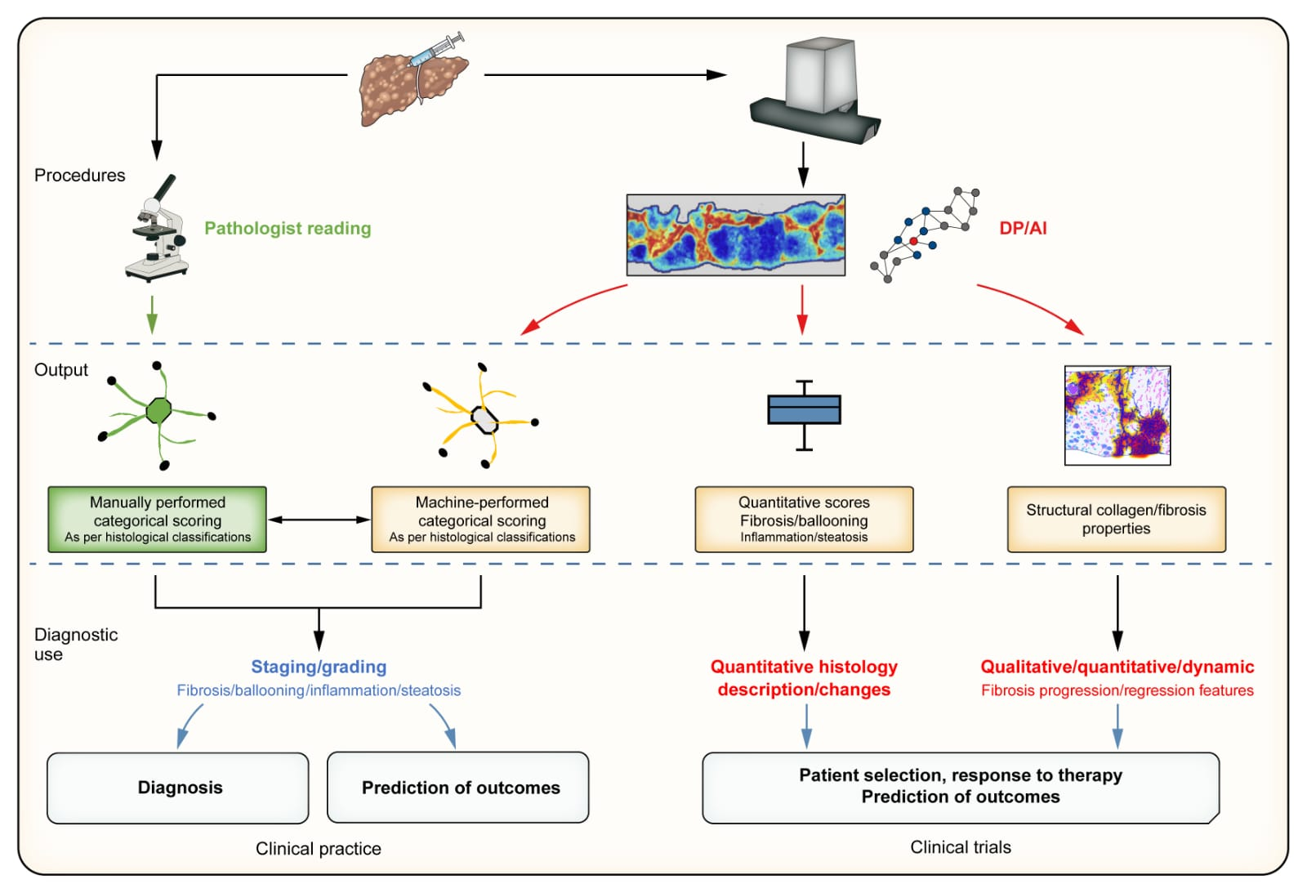

* **Accuracy:** Overall correctness of predictions.
* **Precision:** Proportion of true positive predictions among all positive predictions (minimizes false positives). Crucial if false positives for cirrhosis lead to unnecessary anxiety or invasive tests.
* **Recall (Sensitivity):** Proportion of true positive predictions among all actual positive cases (minimizes false negatives*).* ***Highly important for liver cirrhosis prediction***, as missing a true cirrhosis case can have severe consequences for patient health.
* **F1-Score:** The harmonic mean of precision and recall, providing a balanced measure, especially useful for imbalanced datasets.
* **Area Under the Receiver Operating Characteristic Curve (AUC-ROC):** A robust metric that assesses the model's ability to distinguish between classes across various threshold settings. A higher AUC indicates better discriminatory power.
* **Area Under the Precision-Recall Curve (AUC-PR):** Particularly useful for imbalanced datasets, as it focuses on the performance of the positive class.

By meticulously executing this Model Building phase, we aim to develop highly accurate and reliable machine learning models capable of predicting liver cirrhosis, with a strong emphasis on leveraging the insights derived from diabetes-related patient data. This forms the analytical engine for revolutionizing liver care.

### MILESTONE- 5

### Performance Testing & Hyperparameter Tuning: Predicting Liver Cirrhosis

This phase is critical for optimizing the selected machine learning models to achieve the highest possible accuracy and reliability in predicting liver cirrhosis. It involves systematically fine-tuning the model's internal parameters (hyperparameters) and rigorously evaluating its performance on unseen data to ensure robustness and 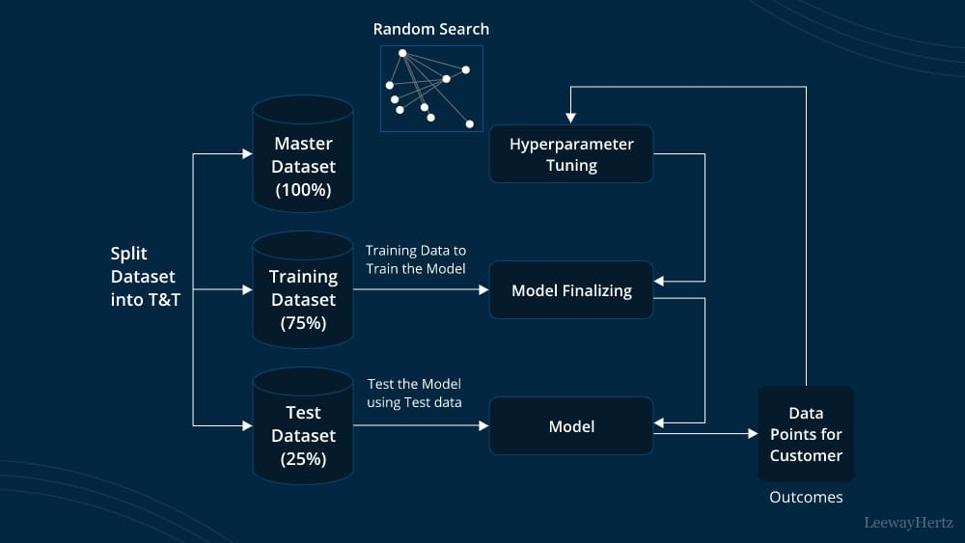generalizability.

**1. The Interplay of Performance Testing and Hyperparameter Tuning:**

Hyperparameter tuning and performance testing are not sequential but rather iterative processes. Hyperparameter tuning a

ims to find the optimal configuration for a model, and performance testing validates how well that optimized model performs.

* **Hyperparameter Tuning:** This process involves searching for the best set of hyperparameters for each chosen machine learning algorithm. Hyperparameters are external configuration parameters whose values are not learned from the data but are set by the data scientist *before* the learning process begins. Their correct setting significantly impacts model performance.
* **Performance Testing (during tuning):** As different hyperparameter combinations are tested, the model's performance is evaluated on a validation set (often through cross-validation) to guide the tuning process. This is an internal evaluation to optimize the model.
* **Final Performance Testing:** Once the optimal hyperparameters are found, the final, tuned model is evaluated on a completely unseen **test set** to provide an unbiased estimate of its real-world performance.

**2. Key Hyperparameters for Each Model (Examples):**

For each machine learning algorithm selected in the "Model Building" phase, specific hyperparameters will be targeted for optimization:

* **Logistic Regression:**
  + C: Inverse of regularization strength. Smaller values specify stronger regularization (to prevent overfitting).
  + penalty: The type of regularization (l1, l2, elasticnet, None).
  + solver: Algorithm to use in the optimization problem (liblinear, saga, lbfgs, etc.).
* **Decision Trees:**
  + max_depth: The maximum depth of the tree (controls overfitting).
  + min_samples_split: The minimum number of samples required to split an internal node.
  + min_samples_leaf: The minimum number of samples required to be at a leaf node.
  + criterion: The function to measure the quality of a split (gini or entropy).
* **Random Forests:**
  + n_estimators: The number of trees in the forest. More trees generally lead to better performance but increase computational cost.
  + max_features: The number of features to consider when looking for the best split.
  + max_depth, min_samples_split, min_samples_leaf: Similar to Decision Trees, but applied to individual trees in the forest.
  + bootstrap: Whether bootstrap samples are used when building trees.
* **Support Vector Machines (SVM):**
  + C: Regularization parameter (penalty for misclassification). Larger C means less regularization.
  + kernel: The kernel function (linear, poly, rbf, sigmoid) to transform data.
  + gamma: Kernel coefficient for 'rbf', 'poly' and 'sigmoid' kernels.
* **Gradient Boosting Machines (XGBoost/LightGBM):**
  + n_estimators: Number of boosting rounds (trees).
  + learning_rate (or eta in XGBoost): Shrinkage factor applied to each tree's contribution.
  + max_depth: Maximum depth of individual trees.
  + subsample: Fraction of samples used for fitting the trees.
  + colsample_bytree: Fraction of features randomly selected for each tree.
  + gamma (XGBoost): Minimum loss reduction required to make a further partition.
  + reg_alpha, reg_lambda: L1 and L2 regularization terms.

**3. Hyperparameter Tuning Strategies:**

Systematic approaches will be employed to efficiently search the hyperparameter space:

* **Grid Search Cross-Validation (GridSearchCV):** This exhaustive method evaluates every possible combination of hyperparameters specified in a grid. It's thorough but can be computationally expensive for large search spaces.
* **Random Search Cross-Validation (RandomizedSearchCV):** This method samples a fixed number of hyperparameter combinations from specified distributions. It's often more efficient than Grid Search, especially for high-dimensional hyperparameter spaces, as it explores the space more effectively.
* **Bayesian Optimization:** A more advanced technique that builds a probabilistic model of the objective function (e.g., cross-validation score) to select the next best hyperparameters to evaluate. It's generally more efficient than Grid or Random Search, as it learns from past evaluations to intelligently explore the search space.
* **Cross-Validation:** During both Grid and Random Search, **K-Fold Cross-Validation** will be used. This involves splitting the training data into K folds, training the model on K-1 folds, and validating on the remaining fold, rotating through all folds. This provides a more robust estimate of model performance than a single train-validation split, ensuring the tuned hyperparameters generalize well.

**4. Performance Metrics for Evaluation:**

The selection of appropriate evaluation metrics is crucial for objectively assessing the model's performance, especially considering the potential class imbalance (fewer cirrhosis cases than non-cirrhosis).

* **For Classification Tasks (Predicting Cirrhosis: Yes/No):**
  + **Accuracy:** (TP + TN) / (TP + TN + FP + FN) - Overall correctness. While a good general metric, it can be misleading for imbalanced datasets.
  + **Precision:** TP / (TP + FP) - The proportion of correctly predicted positive cases out of all predicted positive cases. Important for avoiding false alarms.
  + **Recall (Sensitivity):** TP / (TP + FN) - The proportion of correctly predicted positive cases out of all actual positive cases. **Critically important for liver cirrhosis prediction**, as missing a true positive (false negative) can lead to delayed diagnosis and severe patient outcomes.
  + **F1-Score:** 2 * (Precision * Recall) / (Precision + Recall) - The harmonic mean of precision and recall, providing a balanced measure that is robust to class imbalance.
  + **Specificity:** TN / (TN + FP) - The proportion of correctly predicted negative cases out of all actual negative cases.
  + **Area Under the Receiver Operating Characteristic Curve (AUC-ROC):** This curve plots the True Positive Rate (Recall) against the False Positive Rate (1-Specificity) at various threshold settings. The AUC value (ranging from 0 to 1) provides a single scalar measure of the model's ability to distinguish between classes. A higher AUC indicates better discriminatory power, regardless of the classification threshold.
  + **Area Under the Precision-Recall Curve (AUC-PR):** Particularly valuable for highly imbalanced datasets, as it focuses on the performance of the positive class.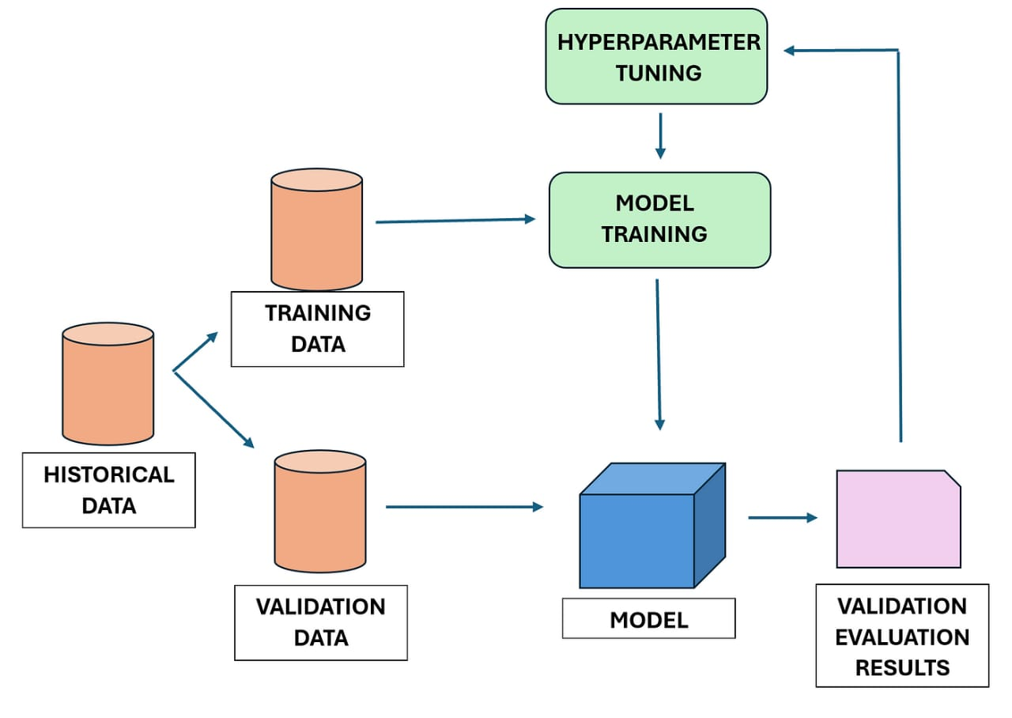

**Confusion Matrix:** A table showing the counts of true positives (TP), true negatives (TN), false positives (FP), and false negatives (FN). It provides a detailed breakdown of classification errors.

**5. Final Model Selection and Evaluation:**

After tuning each model, the following steps will be taken:

* **Comparison of Different Models:** The performance metrics (especially F1-score, Recall, and AUC-ROC) of all tuned models will be compared on the validation sets obtained during cross-validation.
* **Selection of the Best Performing Model(s):** The model(s) that consistently demonstrate superior performance across the chosen metrics will be identified as candidates for the final deployment. Consideration will also be given to factors like interpretability and computational efficiency.
* **Unbiased Evaluation on the Test Set:** The best-performing model(s) will then be evaluated *only once* on the completely unseen **test set**. This provides the most realistic estimate of how the model will perform on new, real-world data. This final evaluation validates the model's robustness and generalizability.

By meticulously executing the Performance Testing and Hyperparameter Tuning phase, the project aims to identify and refine the optimal machine learning model for predicting liver cirrhosis, ensuring it is highly accurate, reliable, and clinically relevant for revolutionizing liver care.

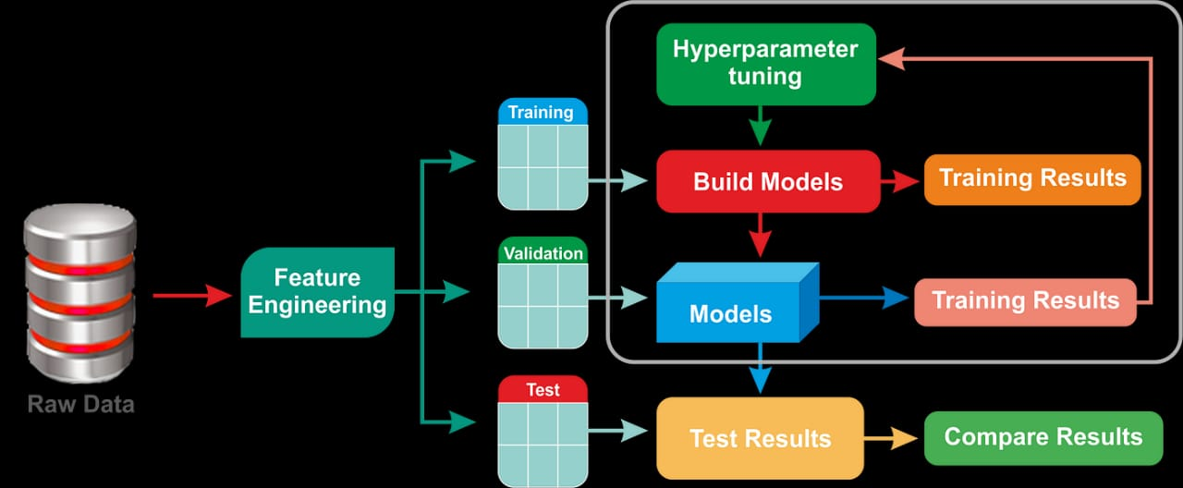

CONCLUSION: Artificial intelligence and machine learning are revolutionizing the prediction and management of liver cirrhosis, offering promising solutions for early detection, risk stratification, and personalized treatment. These advancements have the potential to significantly improve patient outcomes and reduce the burden of liver disease.